TERRAFORM – TASK – 04
==========================================================================

Title
Terraform & Jenkins Automation: Creating Local Files, Managing Variables, and AWS IAM User with Policy Attachment
Objective
The objective of this task is to implement Terraform basic concepts and integrate them with real-time practical execution. The tasks include:
- Initializing Terraform with required providers
- Creating and managing files using Terraform local_file resource
- Using variables with count and for_each
- Reading file content using Terraform data sources
- Handling Terraform errors and fixing them
- Creating AWS IAM user using Terraform and attaching permissions (IAM Policy)
- Installing NodeJS plugin in Jenkins and running NodeJS pipeline using Jenkinsfile
- Understanding basic Maven commands used in build automation
Prerequisites
Before starting this implementation, the following prerequisites are required:
- Terraform Installed
  - Terraform should be installed and accessible in terminal using:
  - terraform -version
- VS Code Setup
  - VS Code installed with Terraform extension (optional)
  - A working folder created for Terraform project
- AWS Account Access (For IAM Task)
  - AWS console access
  - AWS CLI configured using:
  - aws configure
- Jenkins Server Setup (For NodeJS Pipeline)
  - Jenkins installed and accessible in browser
  - GitHub repository created with Jenkinsfile inside
- GitHub Repository Access
  - Repository should contain application code and Jenkinsfile
  - Public repo or Jenkins credentials added for private repo
- NodeJS Plugin Requirement
  - NodeJS plugin must be installed in Jenkins
  - Node version must be configured from Jenkins Tools
Errors Encountered and How I Fixed Them
Error 1: Terraform Data Source File Not Found
Issue:
While running terraform apply, it failed because cats.txt file was missing.
Error shown:
Read local file data source error
The system cannot find the file specified.
Fix:
I created the missing file manually in the same directory using terminal:
echo "I love cats" > cats.txt
Then reran:
terraform apply
Terraform executed successfully after file creation.
Error 2: Inconsistent Dependency Lock File
Issue:
While running Terraform for AWS IAM creation, Terraform showed:
Inconsistent dependency lock file error
This happened because the provider selection was mismatched with lock file.
Fix:
I re-initialized Terraform to update provider details:
terraform init
After that I ran:
terraform apply
The issue was resolved and resources were created successfully.
Error 3: Jenkins Pipeline Failed in Some Stages
Issue:
Pipeline Stage View showed few stages failing (red marks) like build/test due to missing tool setup or dependency issues.
Fix:
- Installed NodeJS plugin in Jenkins
- Configured NodeJS version under: Manage Jenkins → Tools → NodeJS
- Ensured Jenkinsfile was present in GitHub repository
- Re-ran the build again
Pipeline executed successfully with all stages completed.
Conclusion
In this task, Terraform basic concepts were successfully implemented by creating local files, handling variables using count and for_each, and troubleshooting common errors like missing files and dependency lock issues. Additionally, AWS IAM user creation and IAM policy attachment was automated using Terraform. Jenkins was configured with NodeJS plugin and a pipeline was executed using Jenkinsfile from GitHub repository. Overall, this implementation demonstrated end-to-end automation using Terraform and Jenkins, along with practical error handling and successful infrastructure and CI/CD pipeline execution.

2. Execute the script shown in the video.
- Open VS Code and create a folder like Terraform Basic
- Create file:
  - main.tf
- In main.tf, write Terraform provider + local file resource
- Open Terminal inside VS Code
- Run:
- terraform init
- It will download the provider plugin and show Terraform has been successfully initialized

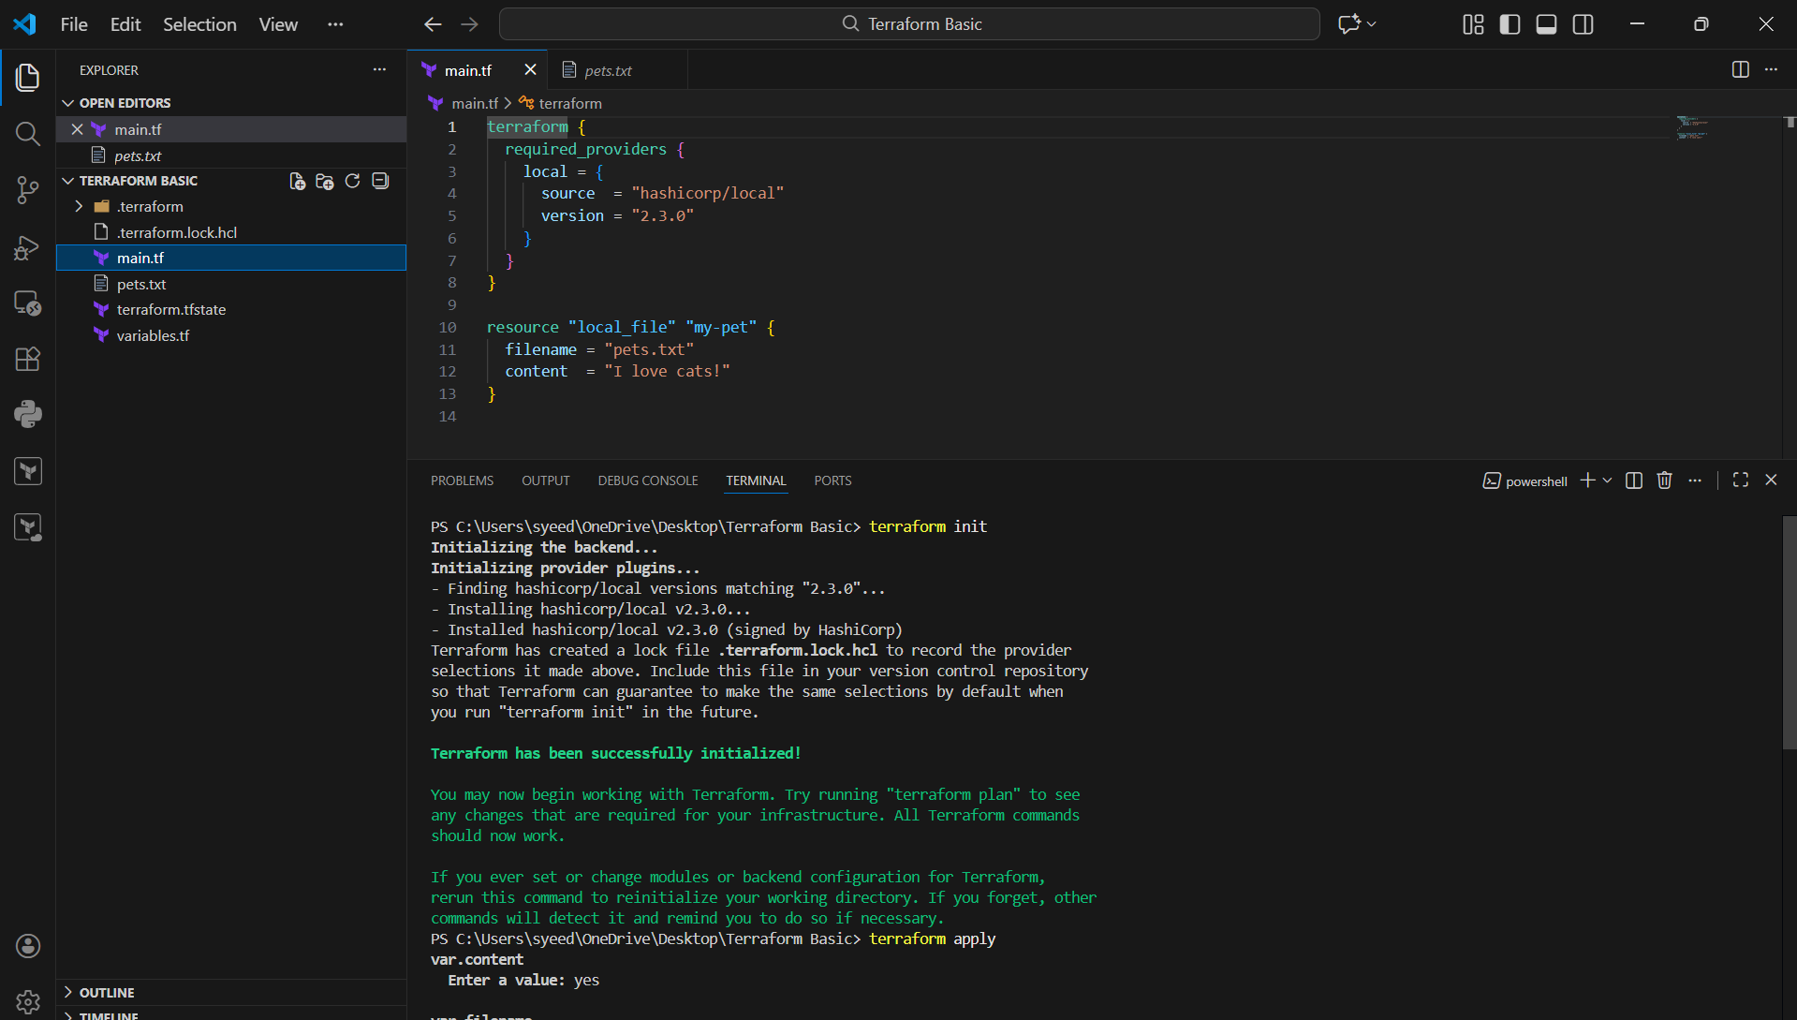
- Open main.tf
- Add this code:
- terraform {
- required_providers {
- local = {
- source = "hashicorp/local"
- version = "= 2.3.0"
- }
- }
- }
- Save the file
- Run:
- terraform init
- It installs the required local provider 2.3.0

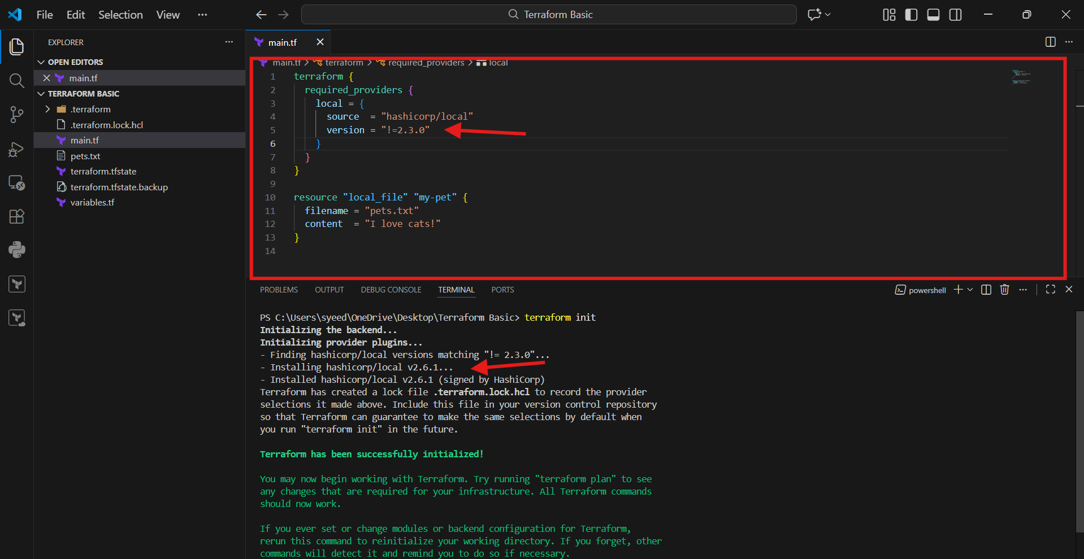

- Change version to:
- version = "< 2.3.0"
- Save the file
- Run:
- terraform init
- Terraform matches and installs a provider version less than 2.3.0

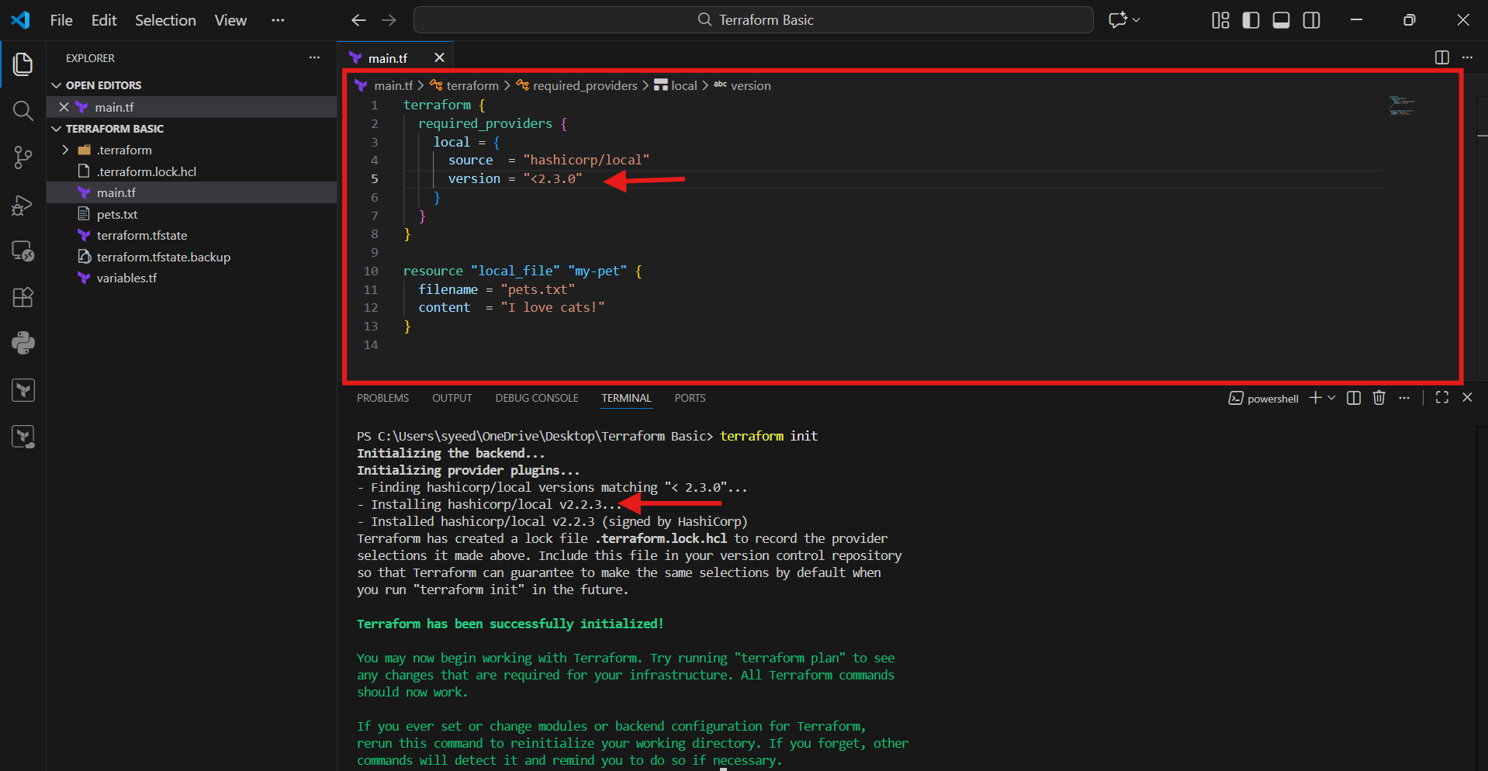
- Update version:
- version = "> 2.3.0"
- Save the file
- Run:
- terraform init
- It installs the version greater than 2.3.0 (latest possible)

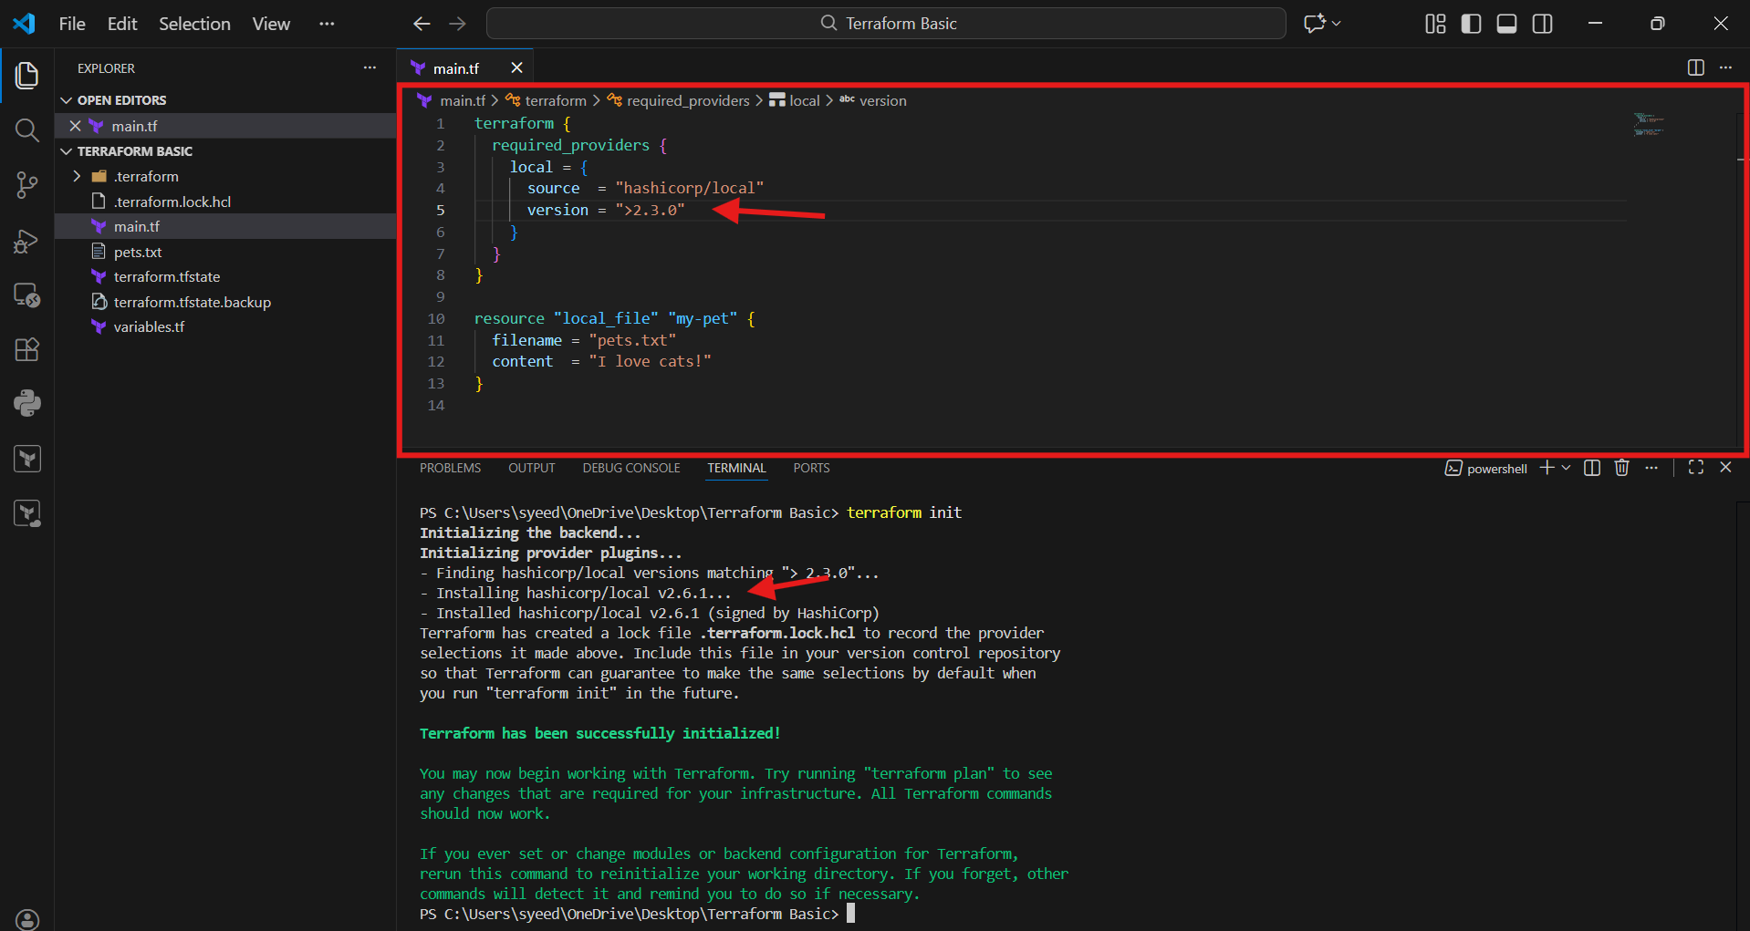
- Change version like this:
- version = "~> 2.3.0"
- Save the file
- Run:
- terraform init
- Terraform will install 2.3.x versions only (patch updates allowed)

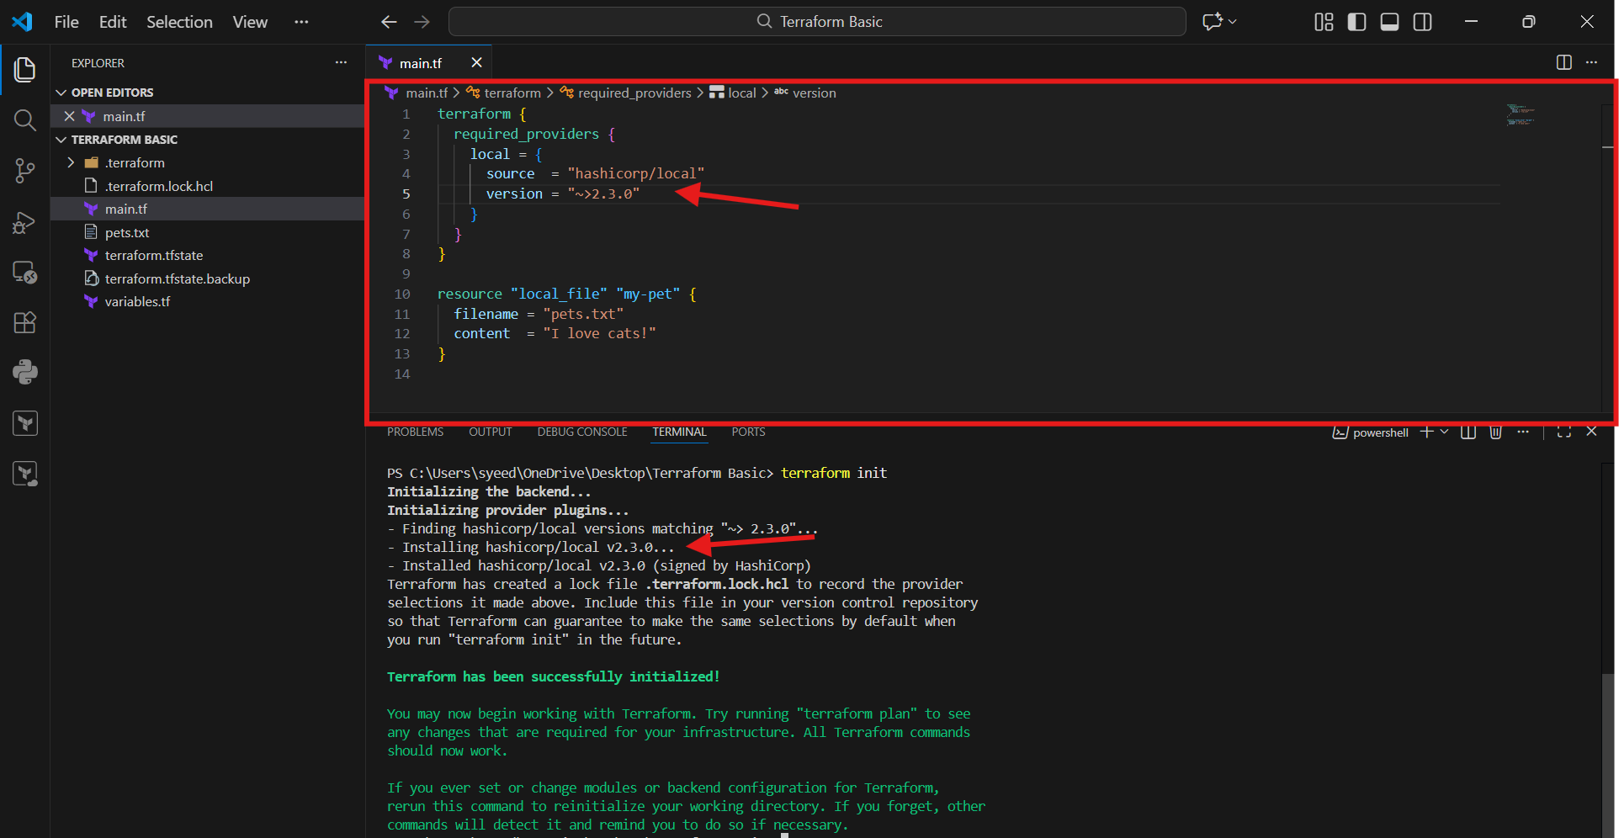
- In main.tf, used a data source:
- data "local_file" "pet" {
- filename = "cats.txt"
- }
- Run:
- terraform apply
- Terraform shows error:
Read local file data source error
File not found (cats.txt missing)

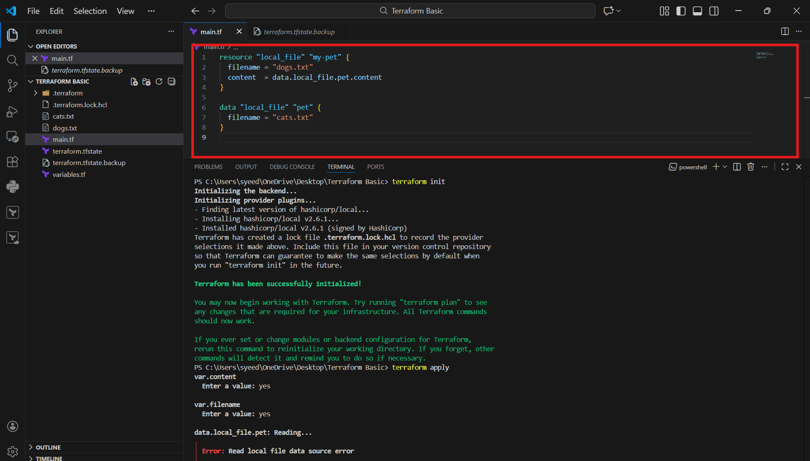
- Create the missing file using terminal:
- echo "I love cats" > cats.txt
- Run again:
- terraform apply
- Now the data source reads successfully and resource gets created

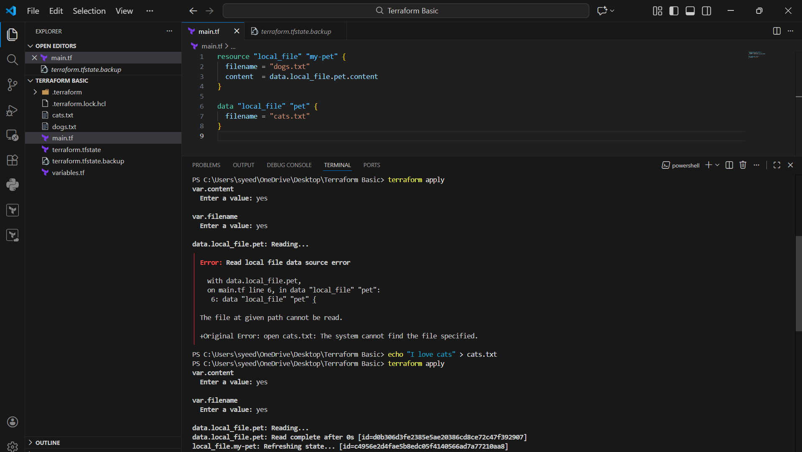
- Terraform shows plan output
- type:
- yes
- Terraform creates the file successfully
- Output shows:
Apply complete! Resources: 1 added

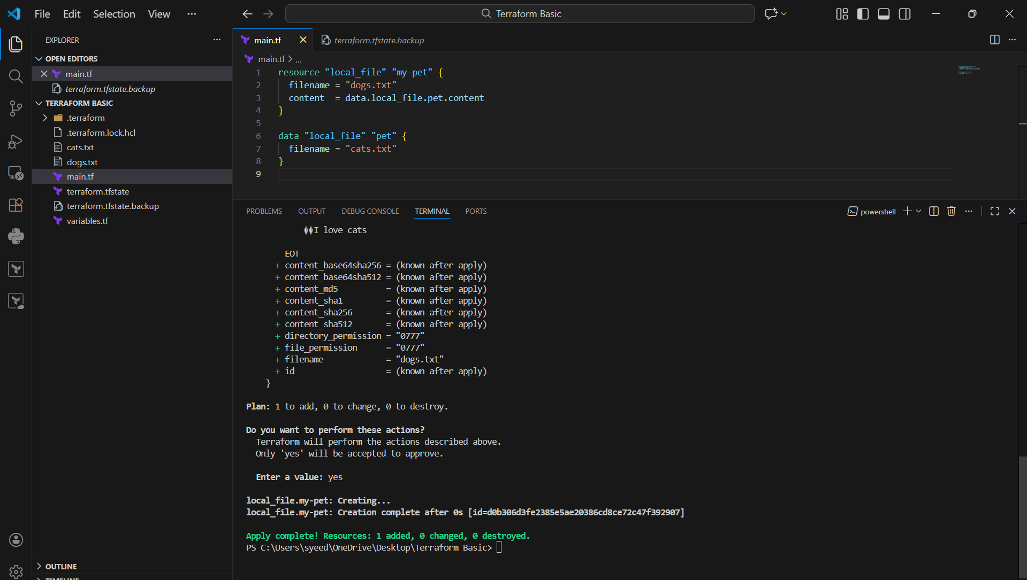
- Open cats.txt in VS Code
- You can see the content:
- I love cats
- This confirms file was created correctly

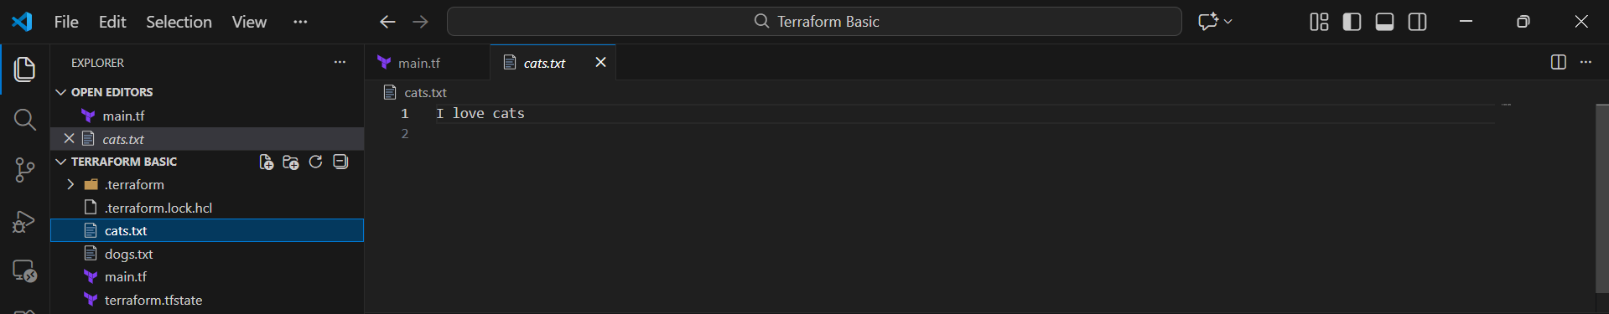
- In main.tf, write:
- resource "local_file" "file" {
- count = 3
- filename = "file-${count.index}.txt"
- content = "Hello Mujju"
- }
- Run:
- terraform apply
- Terraform will create:
  - file-0.txt
  - file-1.txt
  - file-2.txt
- Each file will contain:
- Hello Mujju

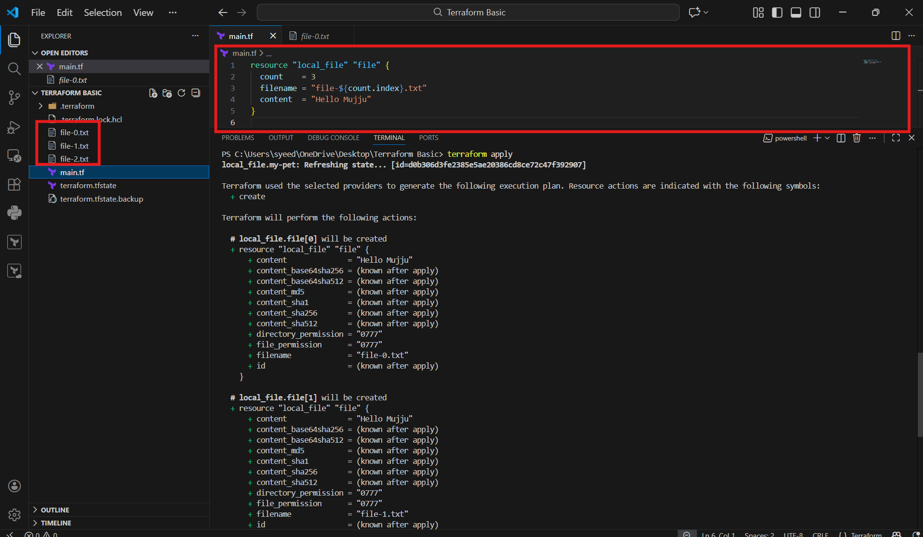

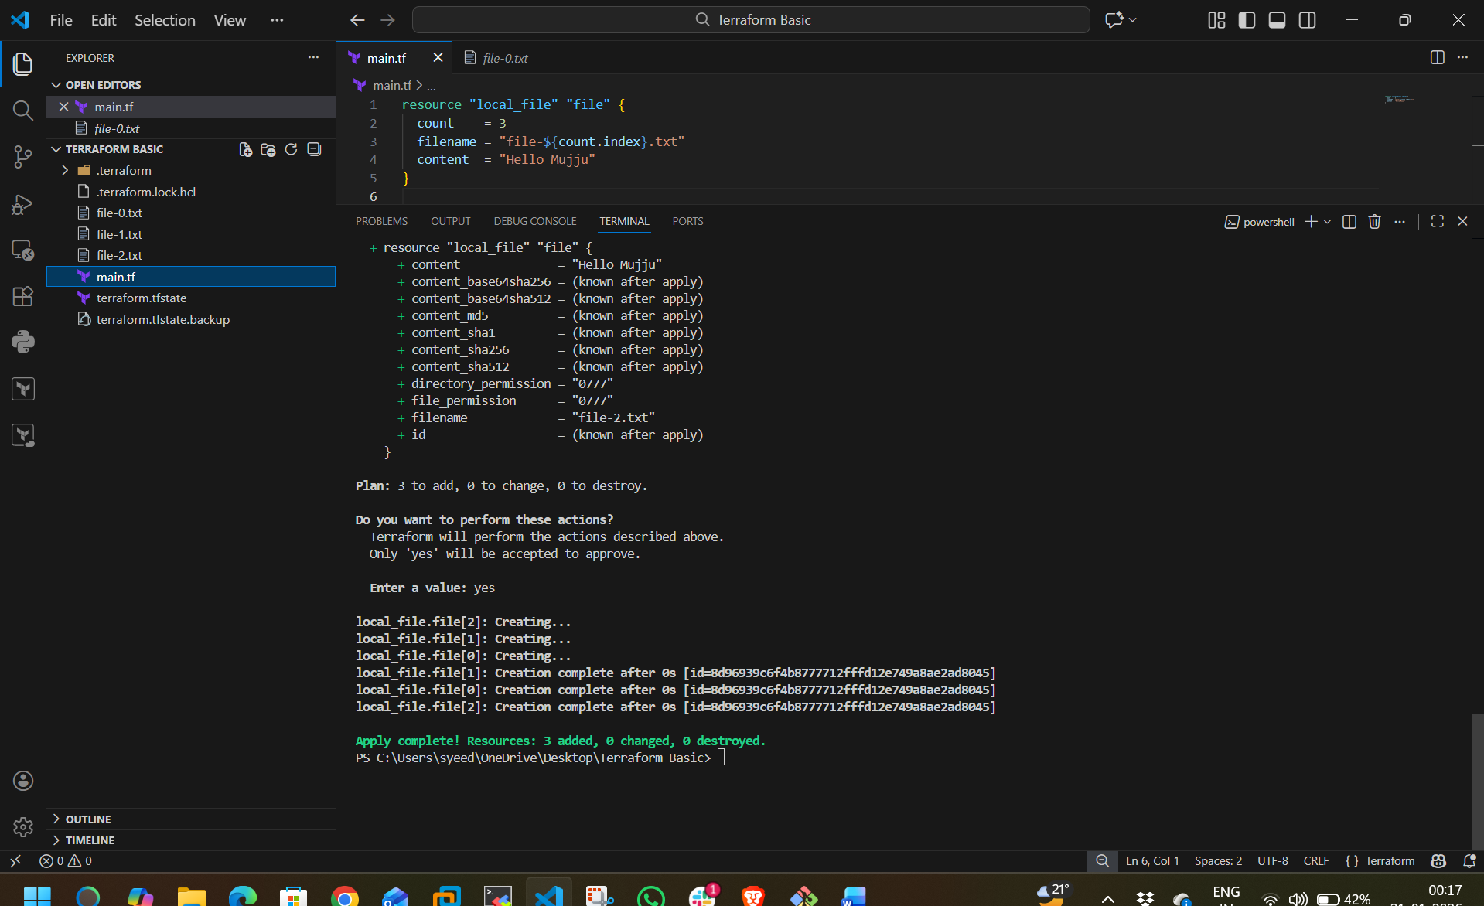
- Open main.tf
- Write this code:
- resource "local_file" "demo" {
- count = var.file_count
- filename = "file-${count.index}.txt"
- content = "Hello Mujju - ${count.index}"
- }
- Step in variables.tf
- Open variables.tf
- Add variable:
- variable "file_count" {
- type = number
- default = 3
- }
- Save both files

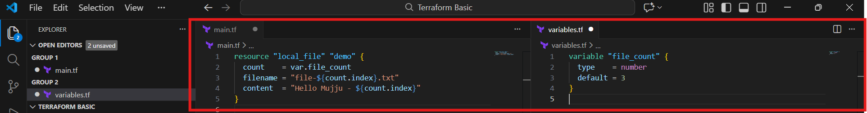
- Run:
- terraform apply
- Terraform refreshes previous created files:
  - local_file.file[0] Refreshing state...
  - local_file.file[1] Refreshing state...
  - local_file.file[2] Refreshing state...
- Terraform generates execution plan for creating the new file resources
- You can also see created files in VS Code Explorer:
  - file-0.txt
  - file-1.txt
  - file-2.txt

- 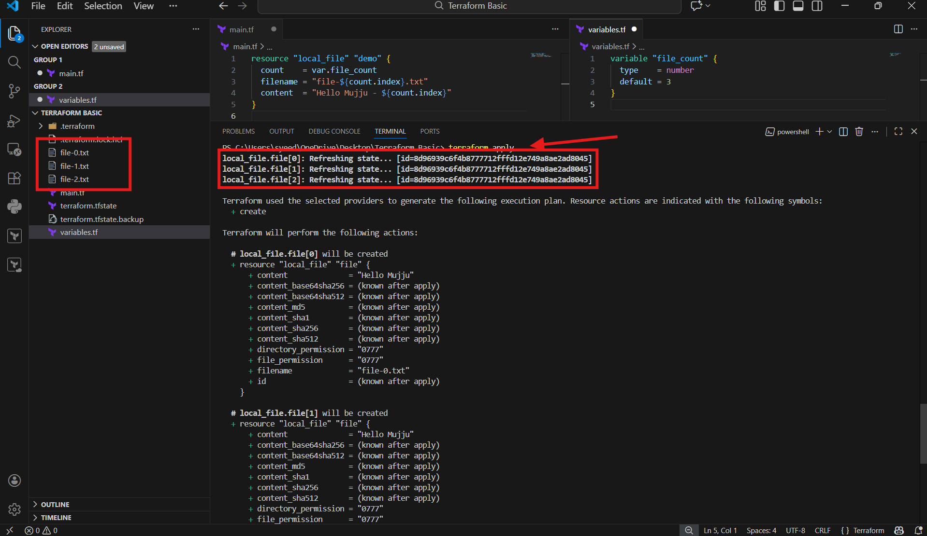
- Open main.tf
- Write for_each block:
- resource "local_file" "my-pet" {
- filename = each.value
- content = var.content[each.key]

- for_each = toset(var.filename)
- }
- Step in variables.tf
- Open variables.tf
- Add list + map variables:
- variable "filename" {
- default = [
- "ironman.txt",
- "love3000.txt"
- ]
- }

- variable "content" {
- default = {
- "ironman.txt" = "I love Iron Man"
- "love3000.txt" = "We love 3000"
- }
- }
- Save files

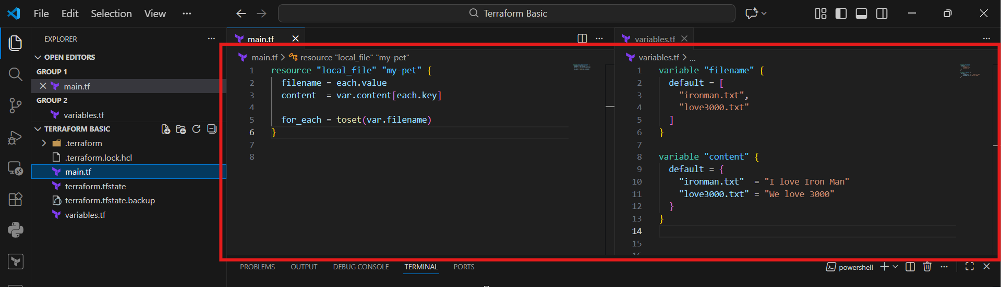
- Run:
- terraform apply
- Terraform starts refreshing state for older resources
- It shows new Plan:
- local_file.my-pet["ironman.txt"] will be created
- local_file.my-pet["love3000.txt"] will be created
- It displays filename and content values from variables

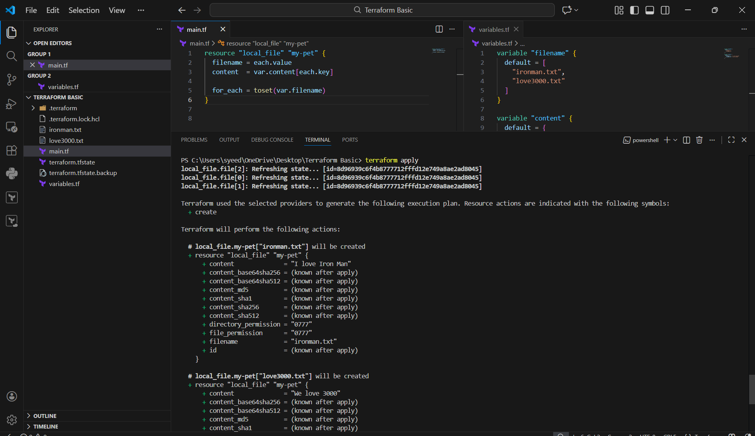
- When Terraform asks:
- Enter a value: yes
- Terraform creates both resources:
  - ironman.txt
  - love3000.txt
- Output shows:
Apply complete! Resources: 2 added

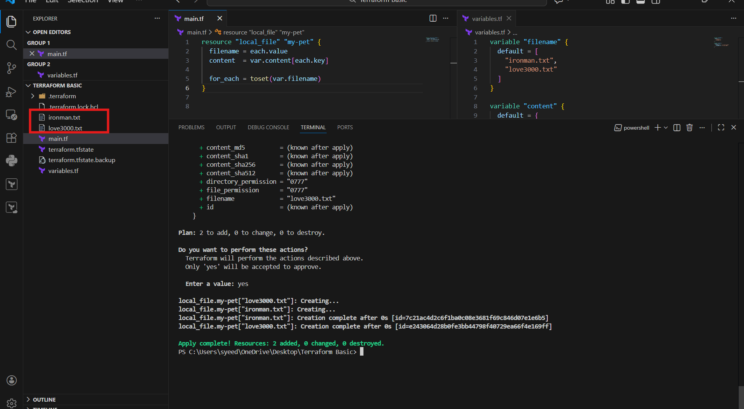
- Open ironman.txt
- Confirm output:
- I love Iron Man
- Open love3000.txt
- Confirm output:
- We love 3000
- This confirms Terraform created both files with correct content

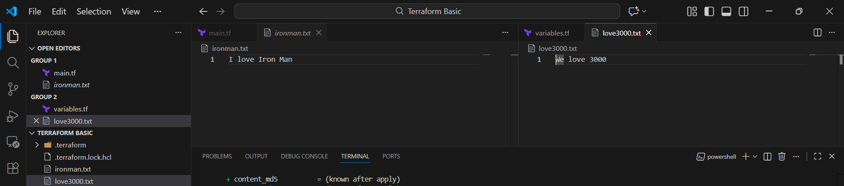
- Login to AWS Console
- Go to:
IAM → Users
- It shows:
Users (0)
- This means no IAM users are created yet in that AWS account

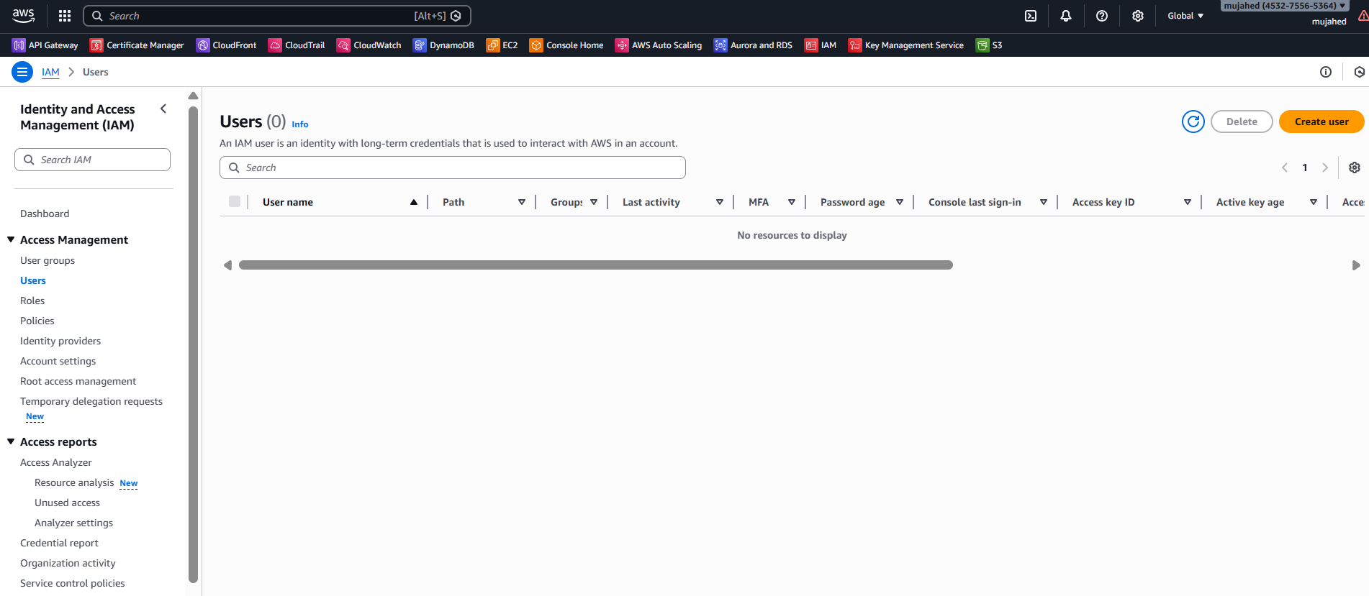
- Write IAM User Resource in main.tf
- Add code:
- resource "aws_iam_user" "admin_user" {
- name = "ironman"

- tags = {
- description = "Technical Team Lead"
- }
- }
- Step 2: Configure AWS CLI Credentials
- Run:
- aws configure
- Enter:
  - AWS Access Key ID
  - AWS Secret Access Key
  - Region (example: ap-south-1)
  - Output format: json
- Step 3: Run Terraform Apply (shows lock file issue)
- Run:
- terraform apply
- got error:
Inconsistent dependency lock file
- Step 4: Fix Error using Terraform Init
- Run:
- terraform init
- It downloads AWS provider and resolves lock file mismatch

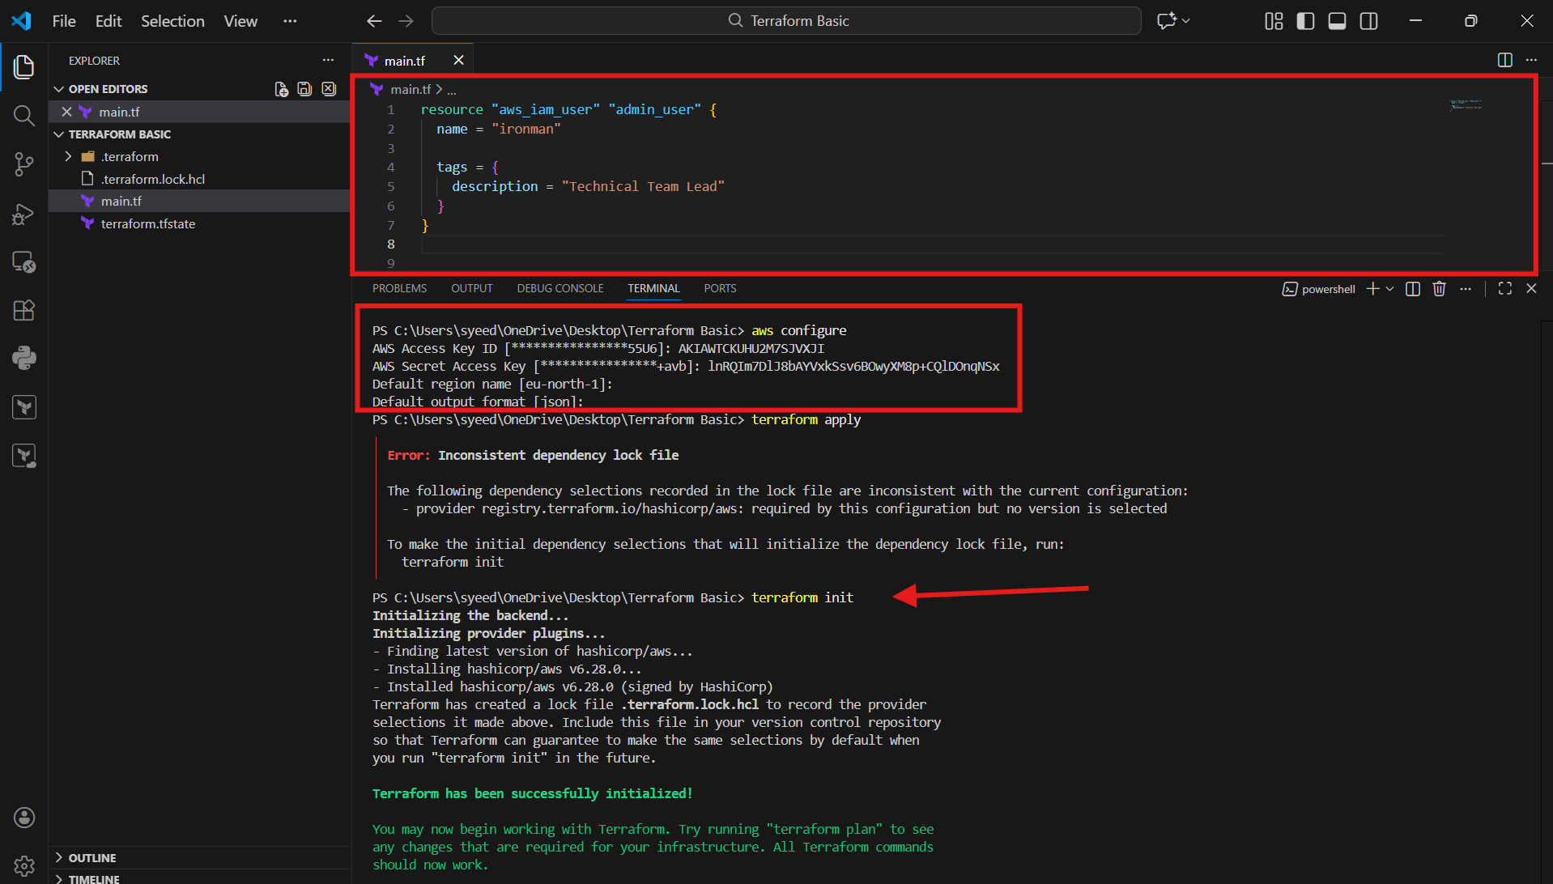
- Run:
- terraform apply
- Terraform displays execution plan:
aws_iam_user.admin_user will be created
- It shows:
- username = ironman
- tags.description = Technical Team Lead
- Enter:
- yes
- Terraform creates the IAM user successfully

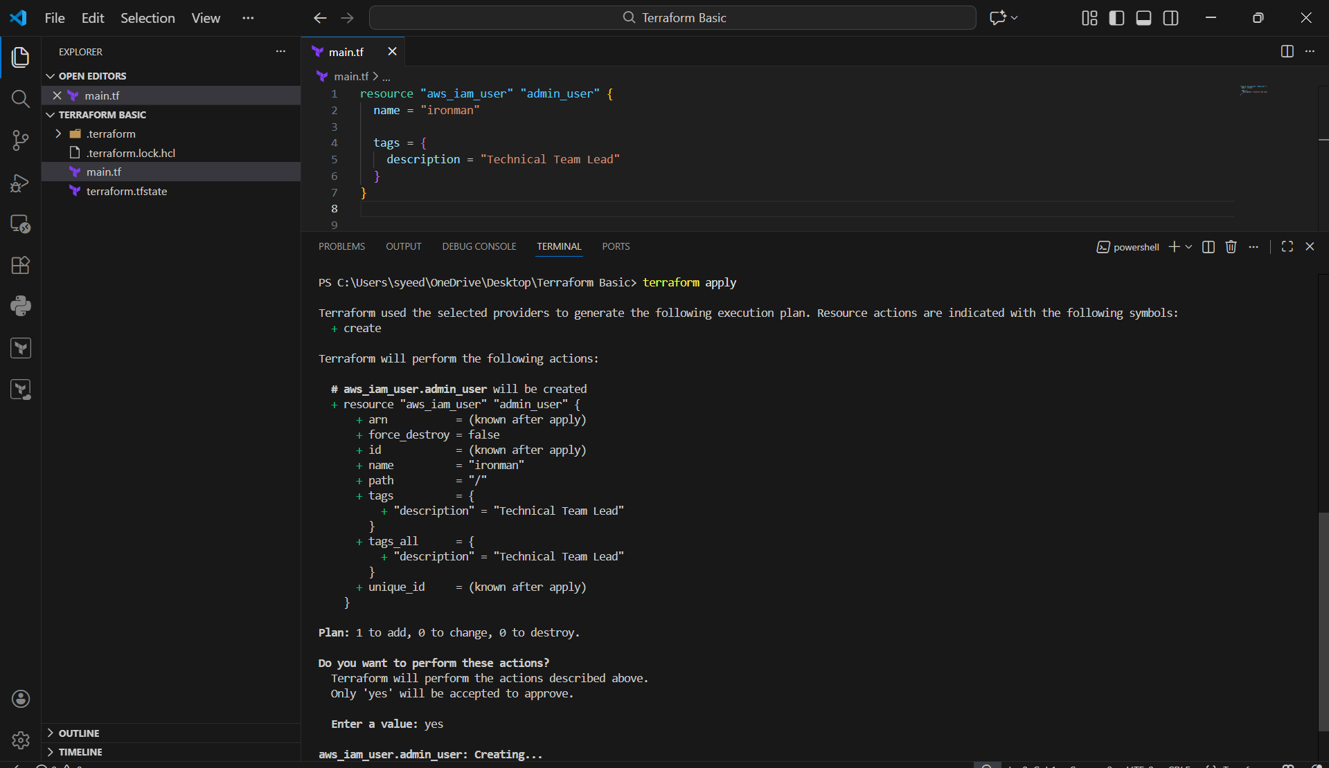
- Useradded succesfully
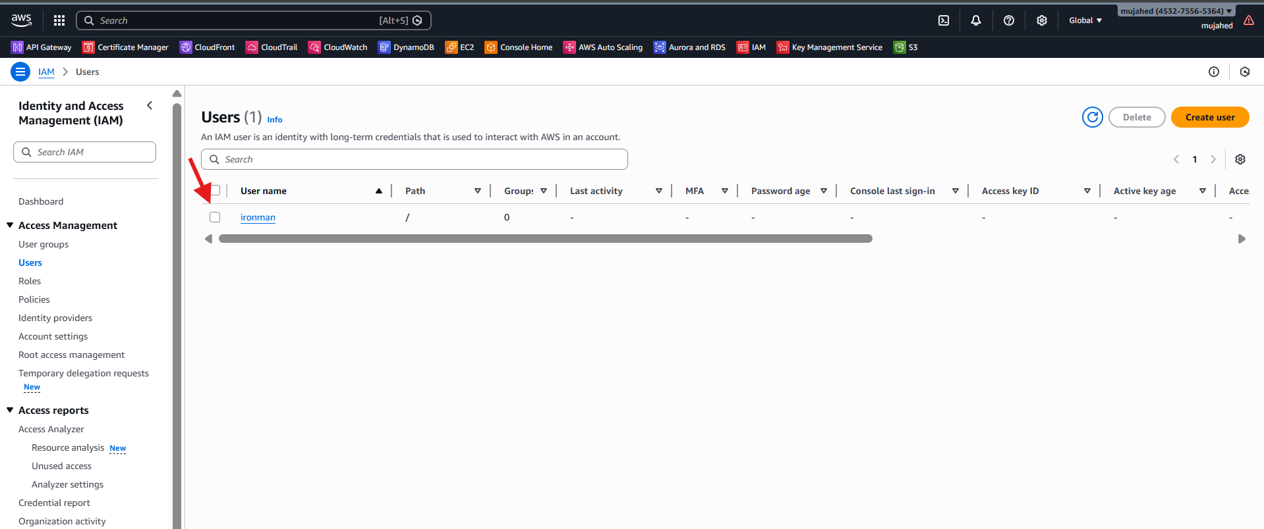
- Login to AWS Console
- Go to:
IAM → Users
- Open the user ironman
- Click Permissions tab
- You can see:
Permissions policies (0)
Meaning: No policy is attached yet, so user has no access permissions.

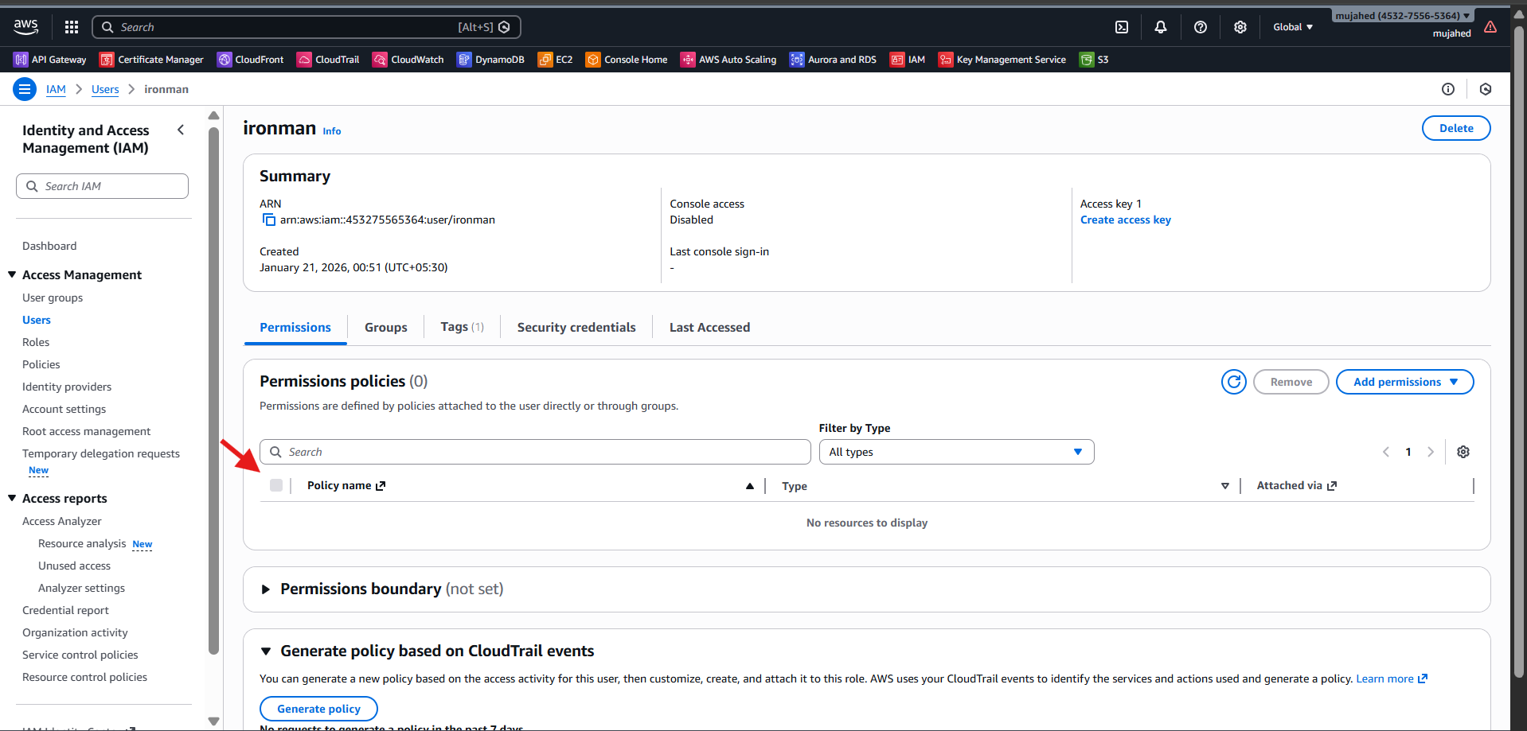
- Open main.tf in VS Code
- Add IAM user resource:
- resource "aws_iam_user" "admin_user" {
- name = "ironman"

- tags = {
- description = "Technical Team Lead"
- }
- }
- Add IAM policy resource:
- resource "aws_iam_policy" "adminuser" {
- name = "AdminUsers"

- policy = <<EOF
- {
- "Version": "2012-10-17",
- "Statement": [
- {
- "Sid": "1234567890",
- "Effect": "Allow",
- "Action": "*",
- "Resource": "*"
- }
- ]
- }
- EOF
- }
- Attach the policy to the user:
- resource "aws_iam_user_policy_attachment" "ironman_admin_access" {
- user = aws_iam_user.admin_user.name
- policy_arn = aws_iam_policy.adminuser.arn
- }
- Save the file

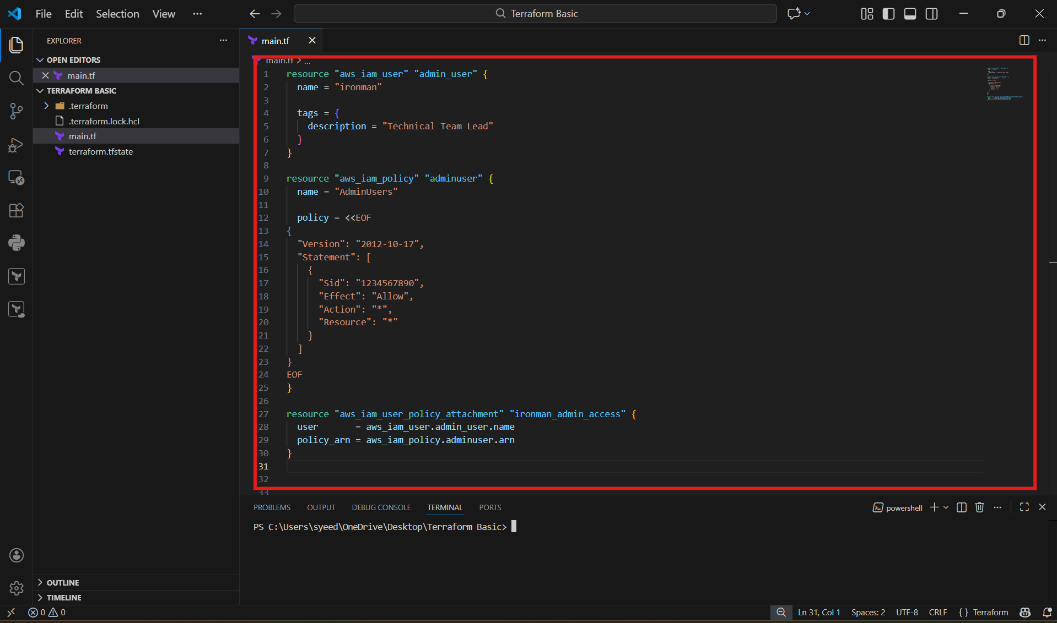
- Open terminal in VS Code
- Run:
- terraform apply
- Terraform shows plan output:
aws_iam_policy.adminuser will be created
- It displays the JSON policy in the plan (Allow "Action": "*")

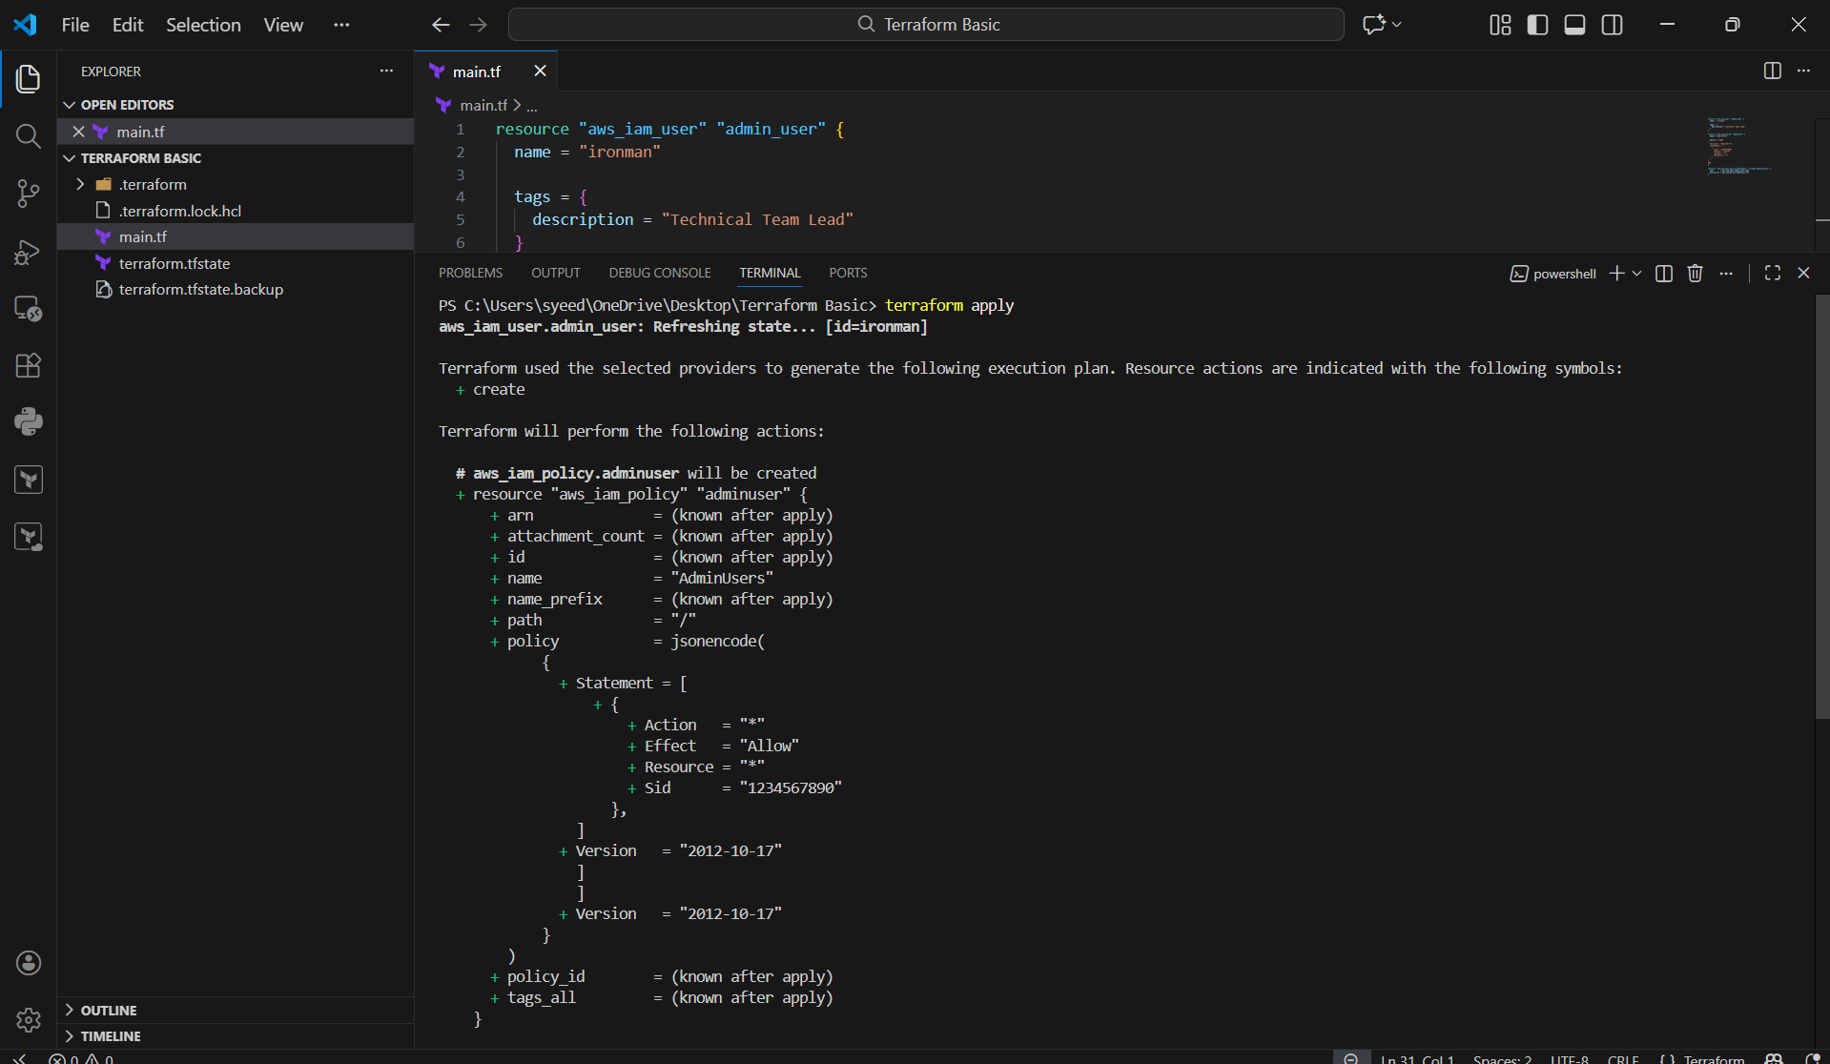
- When Terraform asks confirmation:
- Enter a value: yes
- Terraform creates:
IAM Policy: AdminUsers
Policy attachment to IAM user ironman
- Output shows:
Apply complete! Resources: 2 added

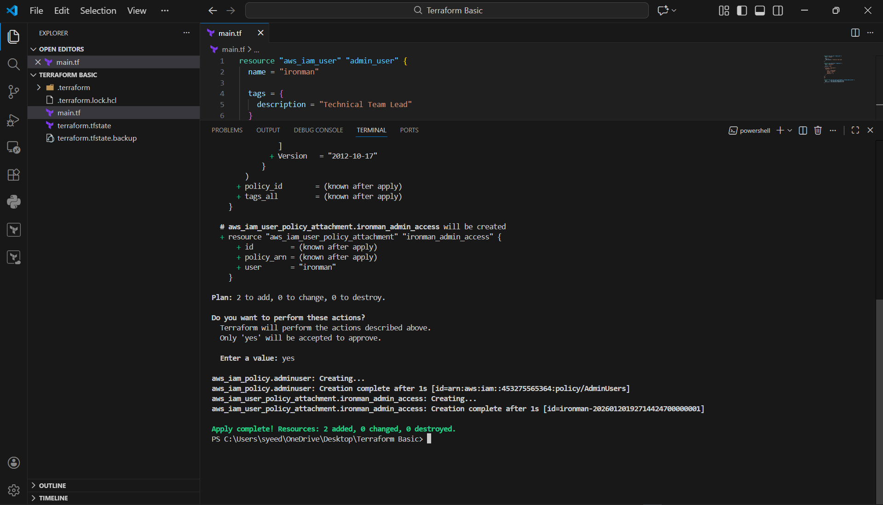
- Go back to AWS Console
- Open:
IAM → Users → ironman → Permissions
- Now you can see:
Permissions policies (1)
- Policy name shows as:
AdminUsers
- This confirms Terraform successfully attached policy to the user

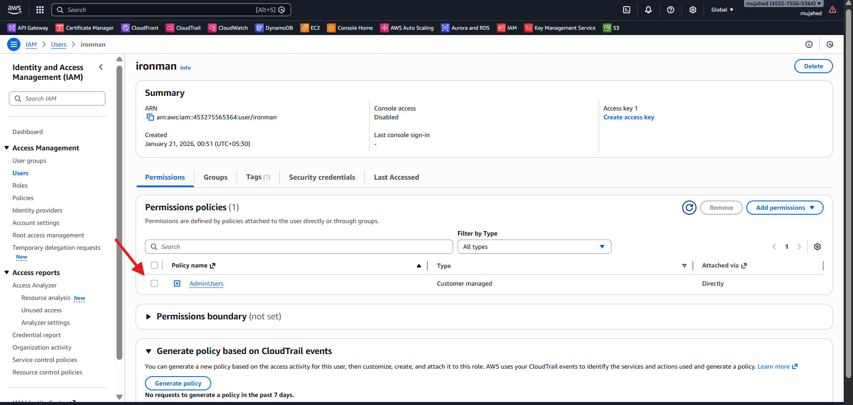

3.Integrate Terraform in Jenkins using the Terraform plugin

- opened main.tf directly in GitHub.
- local_file and random_pet resources reference variables using var.*.
Why this matters
- No hard-coded values.
- Configuration is reusable and CI/CD friendly.

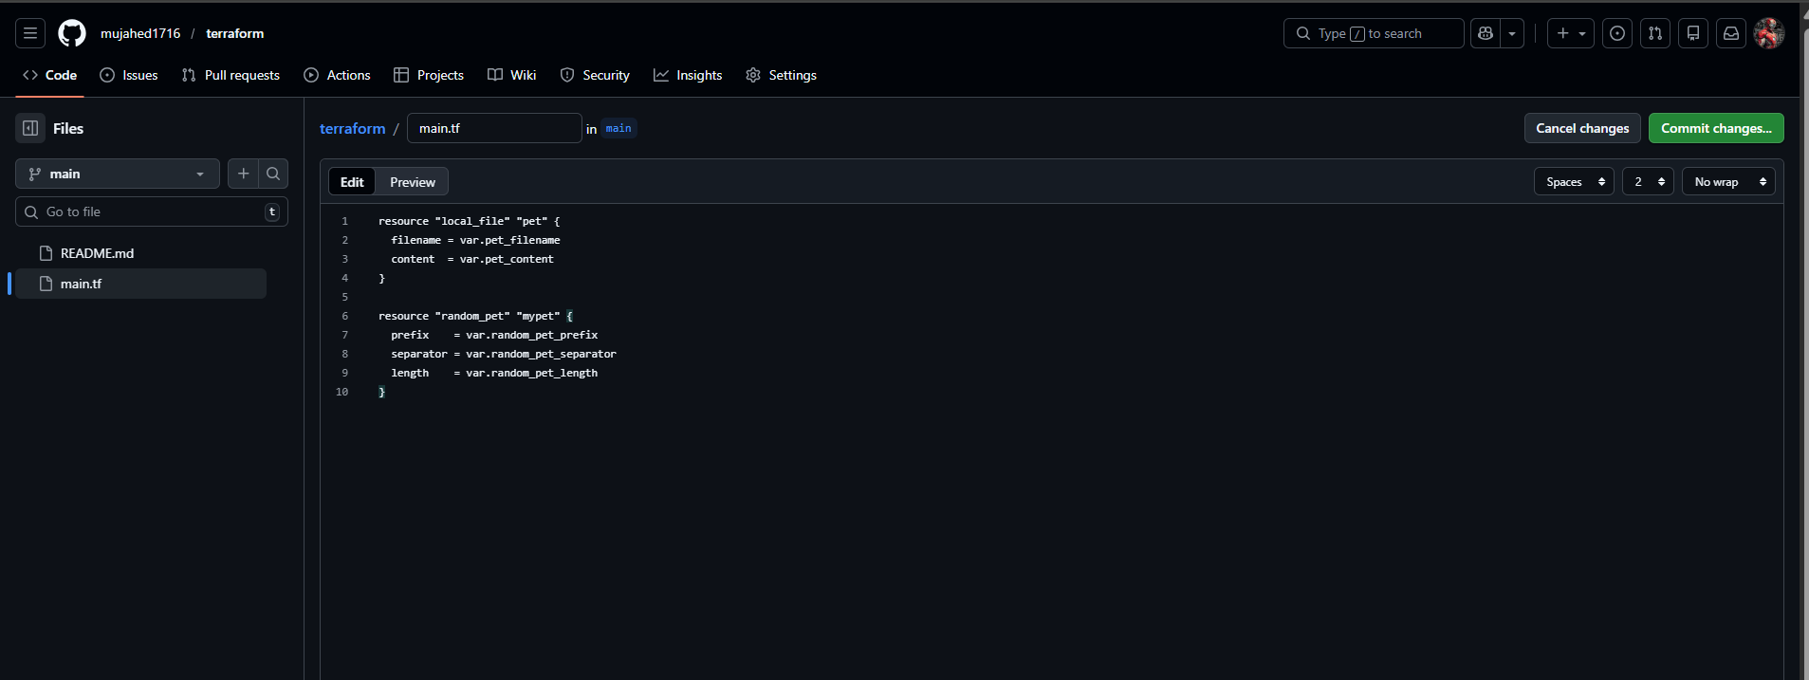
- defined all input variables:
  - pet_filename (now /tmp/pets.txt)
  - pet_content
  - random_pet_prefix
  - random_pet_separator
  - random_pet_length
Why this matters
- Fixes Jenkins permission issue.
- Ensures Terraform config is valid

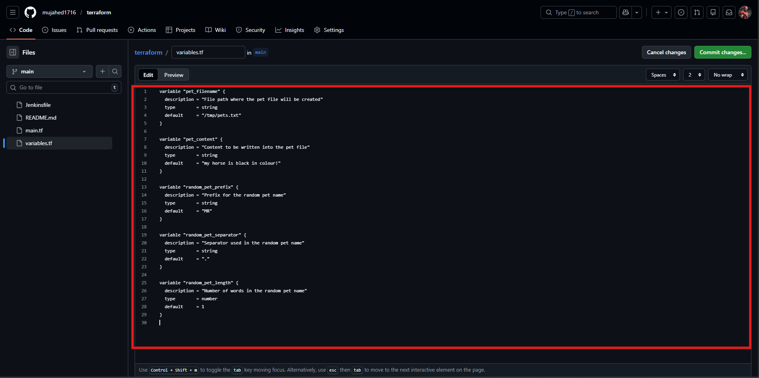
- created a file named Jenkinsfile
- Pipeline stages included:
  - Checkout
  - Terraform Init
  - Terraform Plan
  - Terraform Apply (manual approval)
Why this matters
- Jenkins reads pipeline directly from SCM.
- Follows DevOps best practice (pipeline as code)

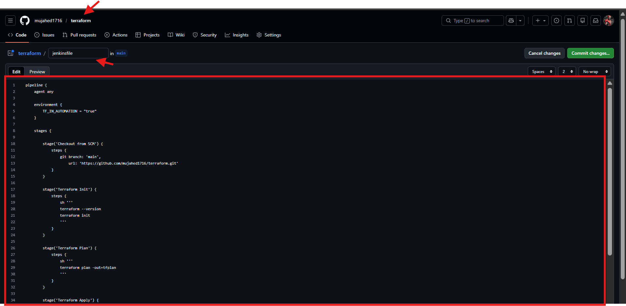

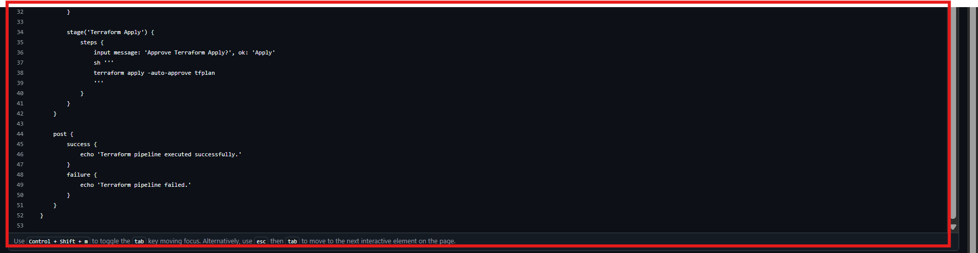
- jenkins → New Item
- Job name: terraform-pipeline-task-02
- Job type: Pipeline

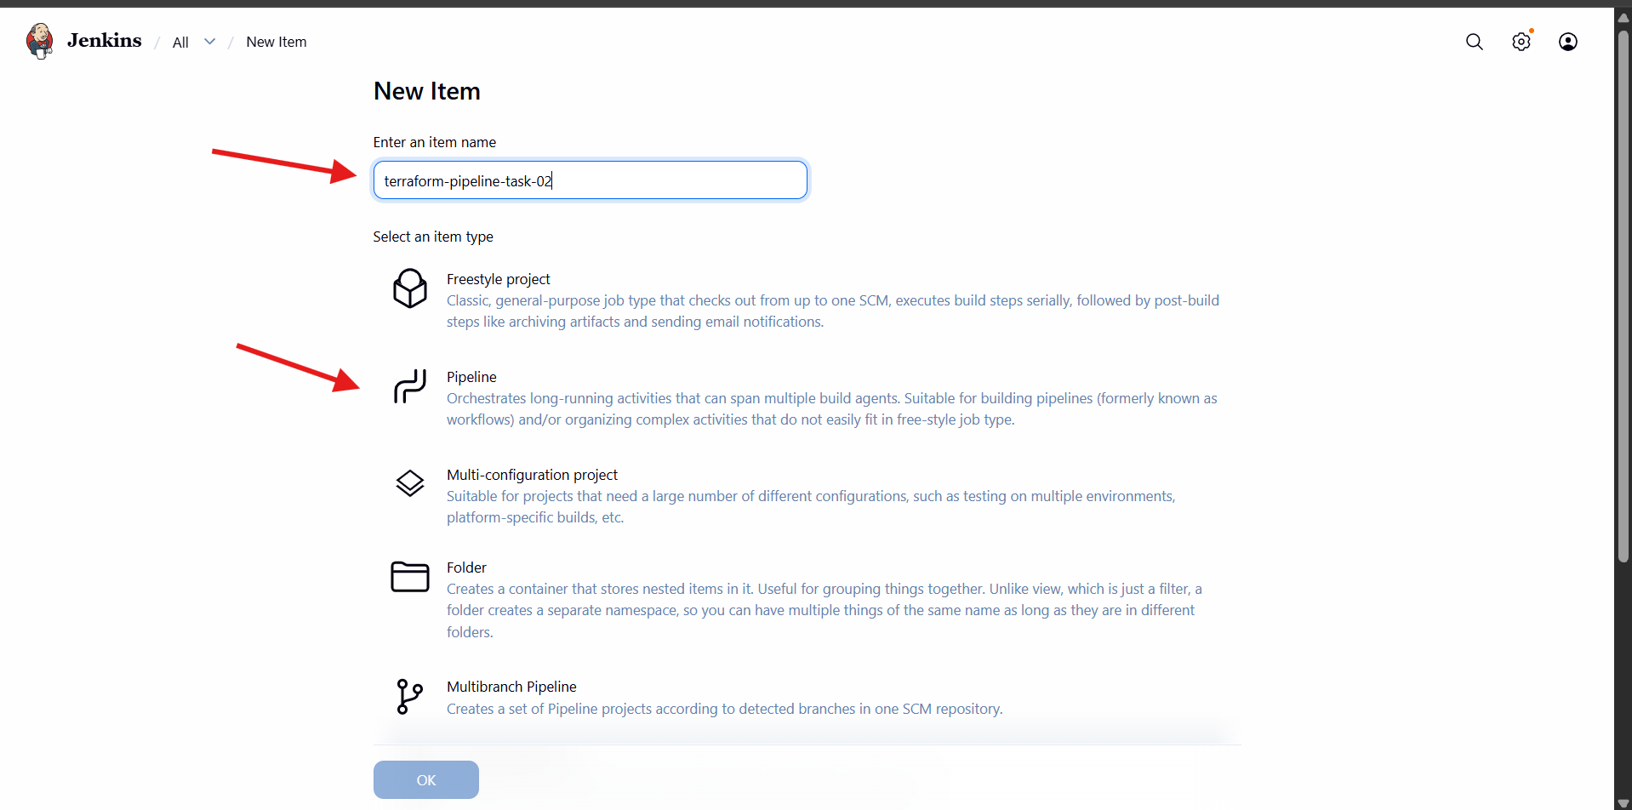
- Definition: Pipeline script from SCM
- SCM: Git
- Repository URL:
- https://github.com/mujahed1716/terraform.git
Why this matters
- Jenkins automatically fetches pipeline code from GitHub.

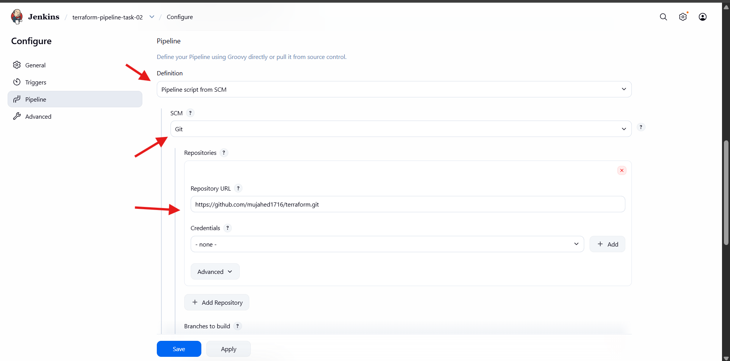
- Branch Specifier:
- */main
- Script Path:
- Jenkinsfile

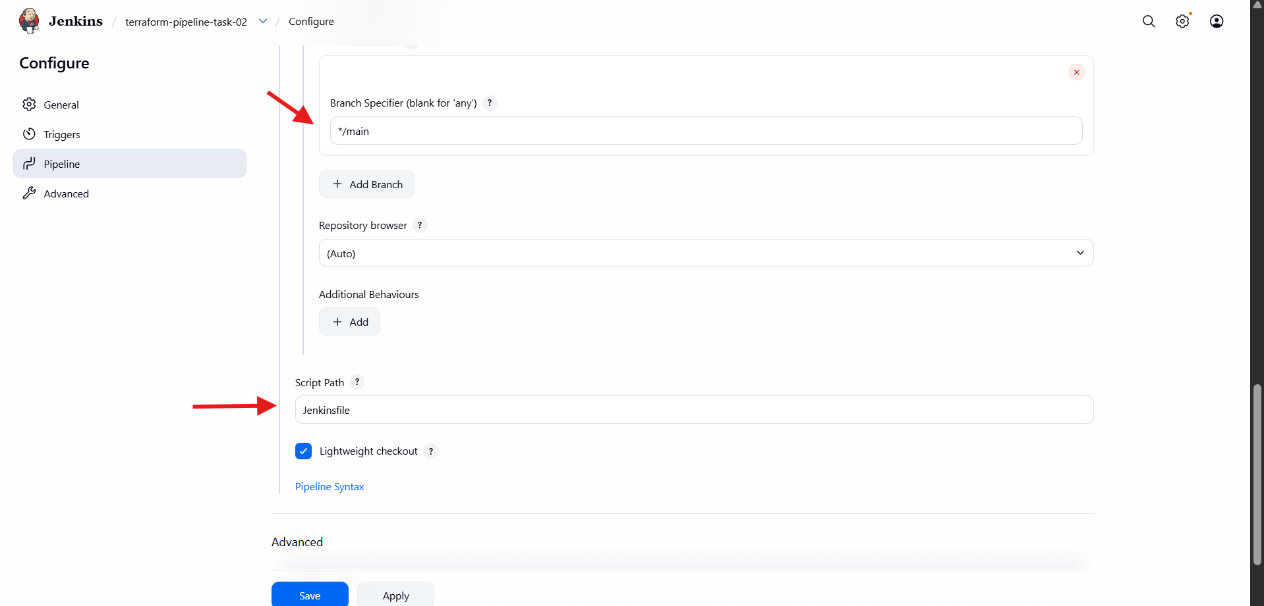
- Build is triggered manually.
- Jenkins performs:
  - Git checkout
  - terraform init
  - terraform plan
  - Manual approval
  - terraform apply
Result
- Resources created successfully.
- File written to /tmp/pets.txt.
- Random pet name generated.

4. Create a CI/CD pipeline for a Nodejs Application: https://github.com/betawins/Trading-UI.git
- Open Jenkins Dashboard
- Go to:
Manage Jenkins → Plugins
- Click Available plugins
- Search for nodejs
- Select NodeJS Plugin
- Click Install (top-right button)
- Wait until plugin installation is completed

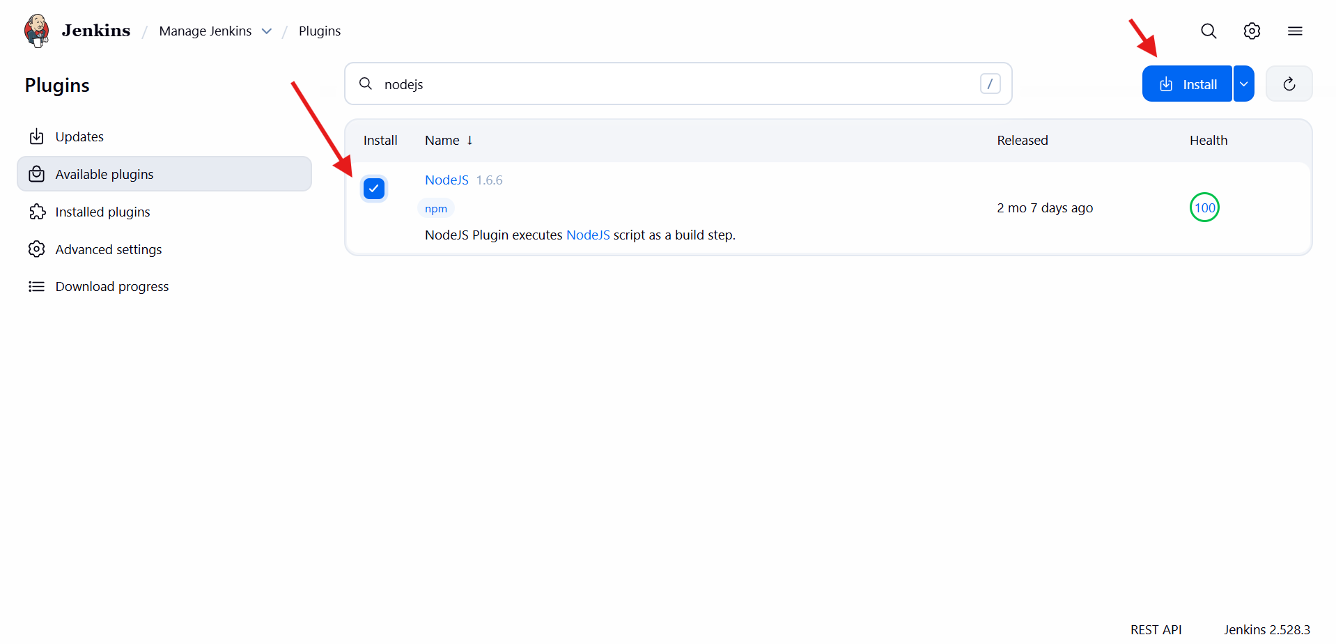
- Go to:
Manage Jenkins → Tools
- Open NodeJS tool configuration again
- Select Node version (example shown: NodeJS 16.0.0)
- Keep Install automatically enabled
- Click Save
This version will be used in Jenkins pipeline builds

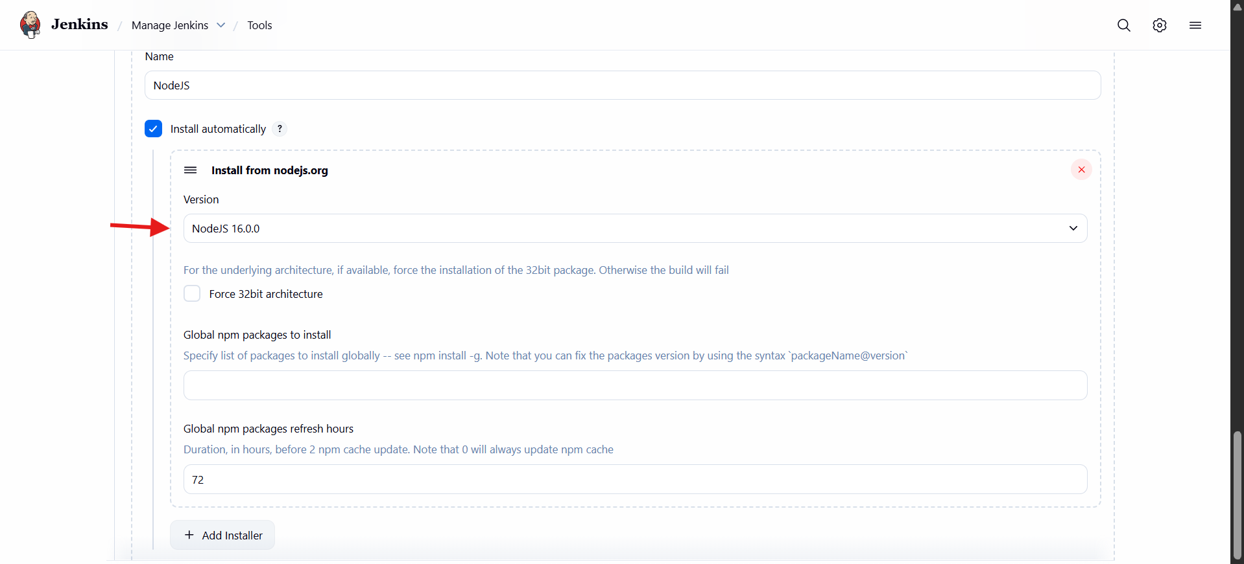
- Open your GitHub repository
- Click on Jenkinsfile
- Add pipeline stages inside Jenkinsfile (Node + npm stages)
- pipeline {
- agent any

- tools {
- nodejs "NodeJS"
- }

- stages {
- stage('Checkout') {
- steps {
- git url: 'https://github.com/mujahed1716/Trading-UI.git', branch: 'master'
- }
- }

- stage('Check Node & NPM') {
- steps {
- sh 'node -v'
- sh 'npm -v'
- }
- }

- stage('Install Dependencies') {
- steps {
- sh 'npm install'
- }
- }

- stage('Build') {
- steps {
- sh 'CI=false npm run build'
- }
- }

- stage('Test') {
- steps {
- sh 'npm test || echo "No tests found"'
- }
- }
- }
- }
- Save the Jenkinsfile and Commit changes

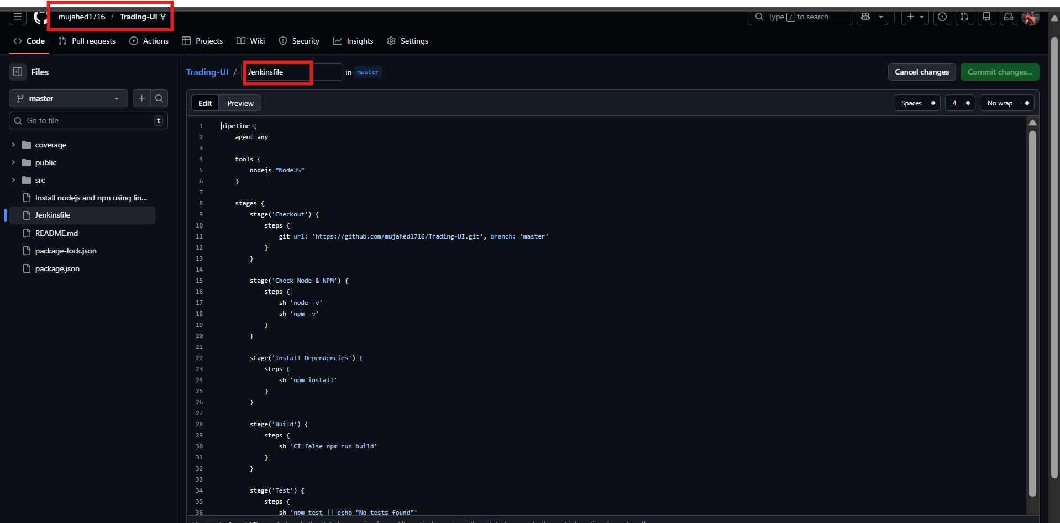
- Open Jenkins Dashboard
- Click New Item
- Enter job name:
nodejs
- Select:
Pipeline
- Click OK

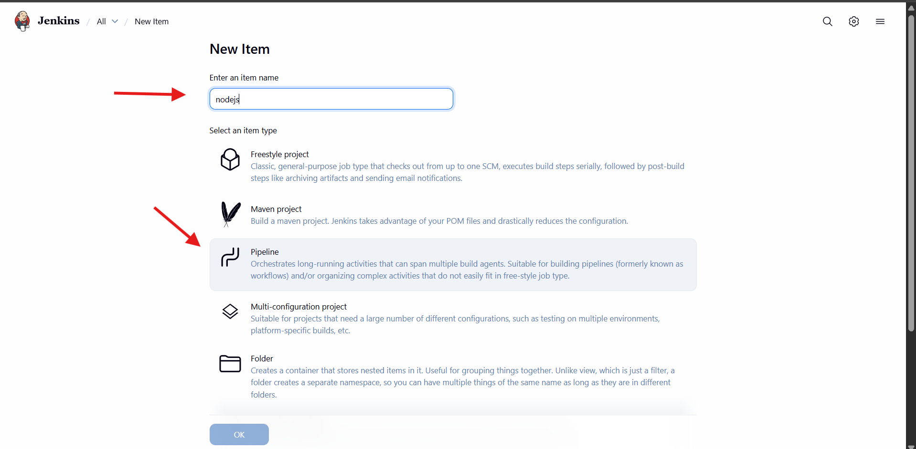
- Inside job configuration, go to Pipeline
- In Definition, select:
Pipeline script from SCM
- In SCM, choose:
Git
- Under Repository URL, enter GitHub repo link
Example:
- https://github.com/mujahed1716/Trading-UI.git
- Click Save

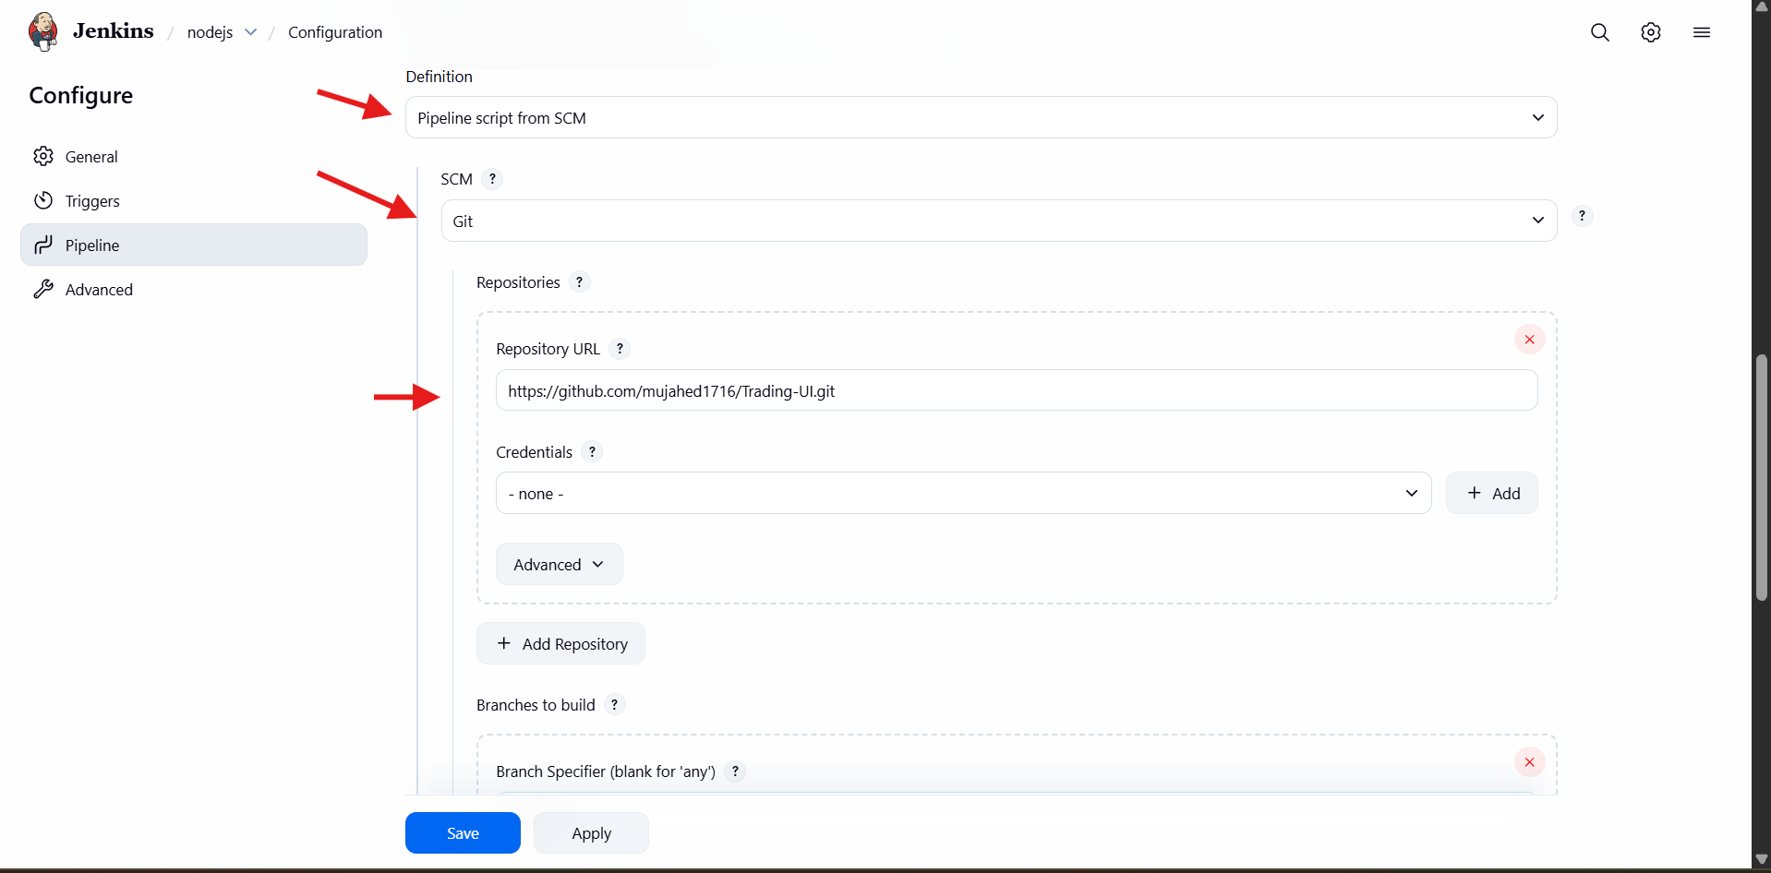
- In the same Pipeline configuration page:
- Under Branches to build
- Add branch:
- */master
- (or */main if your repo is main branch)
- In Script Path, type:
- Jenkinsfile
- Click Save / Apply

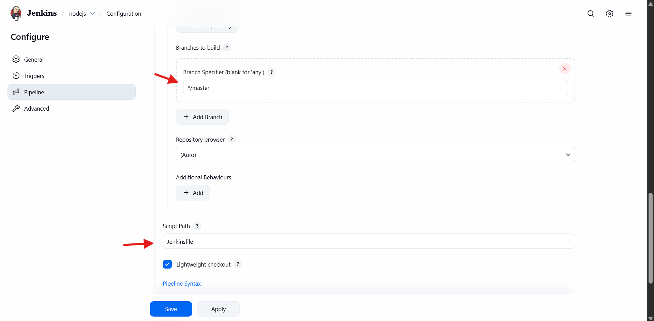

- Open Jenkins job: nodejs
- Click the build history build number
- Open Stage View
- You can see pipeline stages like:
- Checkout SCM
- Tool Install
- Checkout
- Check Node & NPM
- Install Dependencies
- Build
- Test
•
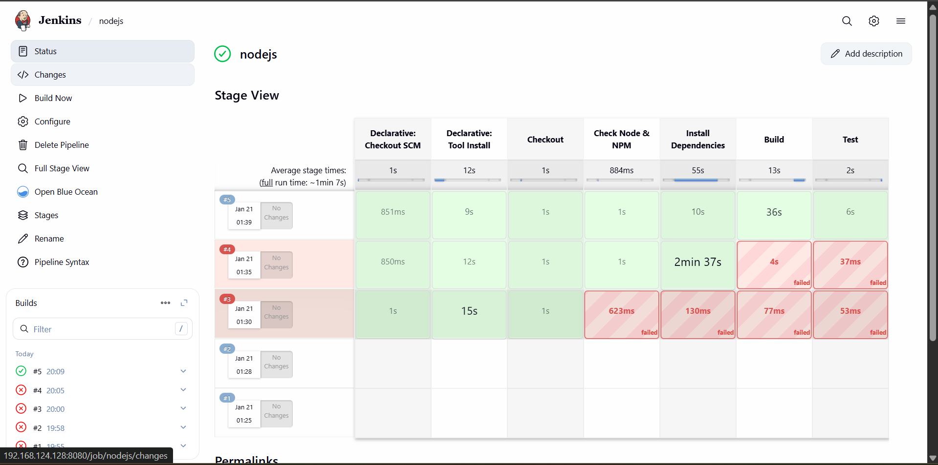

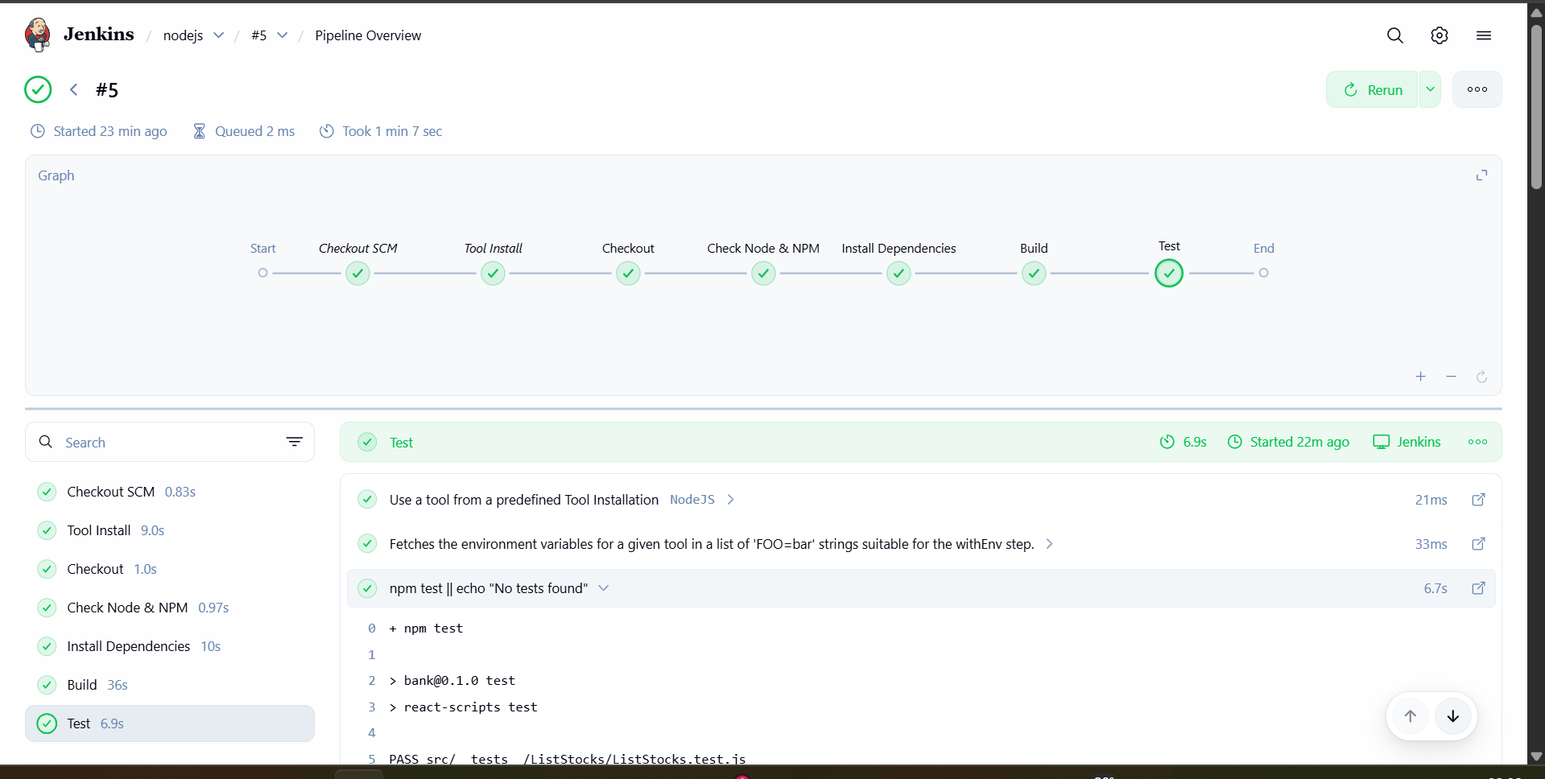

5. Explain 10 Maven commands.

- 1) mvn -version
Checks Maven version + Java version installed.
- 2) mvn clean
Deletes the old compiled files (removes target/ folder).
- 3) mvn compile
Compiles the source code from src/main/java.
- 4) mvn test
Runs unit test cases from src/test/java.
- 5) mvn package
Builds the project and creates a JAR/WAR file inside target/.
- 6) mvn install
Installs the built artifact into local Maven repo (~/.m2/repository).
- 7) mvn validate
Checks if the project structure and pom.xml are correct.
8) mvn clean install
First cleans the old build, then builds and installs fresh package.
- 9) mvn dependency:tree
Shows dependency hierarchy (which dependency depends on what).
- 10) mvn deploy
Uploads the final package to a remote repository (Nexus/Artifactory).

